Reset of TN2220

Instruction of reset：

- error with the yellow light on（as photo）
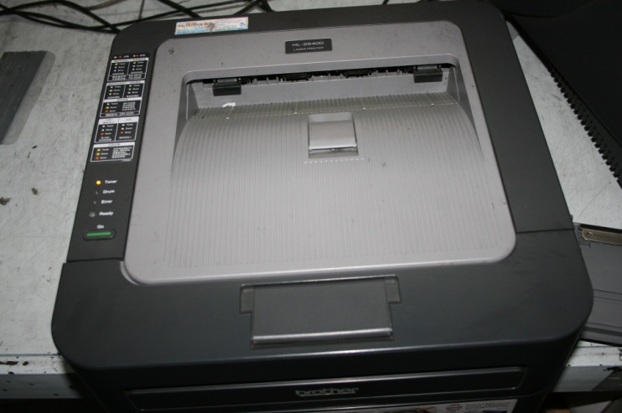
- pull the cover
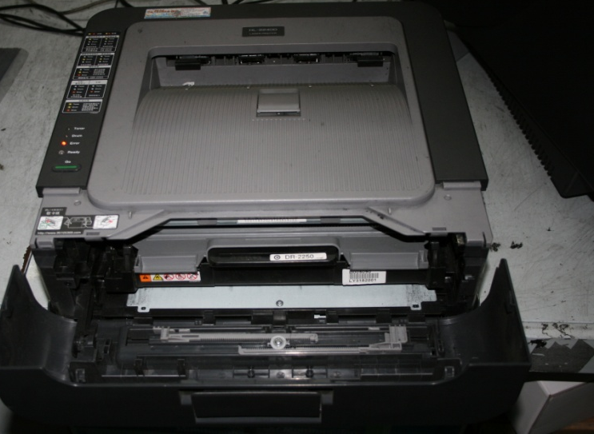
- close the cover (green light is on)
